SUBHALINA GHOSH

Kolkata, India, West Bengal • 7059548761 • ghoshsubhalina@gmail.com  
https://subhsg.github.io/Subhalina-Ghosh-Portfolio/

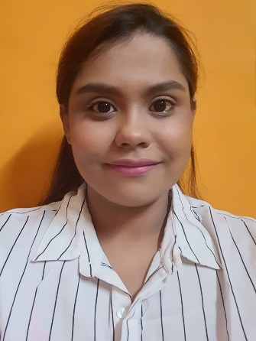

System Engineer at Tata Consultancy Services

Summary

Enthusiastic, self–motivated and seasoned IT professional aspiring to be an Frontend Developer with 2.5+ years of progressive experience in testing domain. I am IT professional with hands-on experience in financial sector projects. My innate ability to learn quickly and adapt has propelled me to become a self-taught web developer, with a strong aspiration to excel as a front-end specialist.

Work experience

Nov 2020 – Present System Engineer - Testing

*Tata Consultancy Services*

*I have hands-on experience in financial sector projects. I have undertaken the responsibility for looking onto all the processes of Policy Admin in the testing domain. I have mastered the BANCS testing and fluently use the ALM tools. I have been appreciated for my database knowledge and navigating the database for the project in PLSQL. I have been awarded and appreciated for my manual testing skills and delivery of projects and assignments on time.*

Courses

|  |  |
| --- | --- |
| DIGITAL: JAVASCRIPT ESSENTIALS_FP | TCS ( IEVOLVE- DIGITAL)  21-04-2023 |
| DIGITAL: STYLING WITH CSS_FP | TCS ( IEVOLVE- DIGITAL)  12-04-2023 |
| DIGITAL: HTML5 SEMANTIC ELEMENTS_FP | TCS ( IEVOLVE- DIGITAL)  10-04-2023 |

Education

,

|  |  |
| --- | --- |
| B.TECH IN ELECTRICAL ENGINEERING | NETAJI SUBHASH ENGINEERING COLLEGE ( MAKAUT )  2016 - 2020 |
|  |  |

Achievements

Awarded with On The Spot Award on 07-Aug-2023 at TCS.

Awarded with Star Team Award on 07-Aug-2023 at TCS.

Awarded with Best Team Award on 28-Jun-2023 at TCS.

Awarded with On The Spot (Team) Award on 29-Dec-2022 at TCS.

Awarded with Best Team Award on 26-Sept-2022 at TCS.

Awarded with On The Spot (Team) Award on 02-Aug-2022 at TCS.

Awarded with Best Team Award on 01-Oct-2021 at TCS.

Awarded with Best Team Award on 05-Jul-2021 at TCS.

Personal Details

Date of Birth: 18 .01. 1998  
Gender: Female  
Marital Status: Single   
Languages Known: English, Bengali, Hindi & Korean   
Interests: Painting , Writing